The main application has been deployed in VM

1.click on the eclipse shortcut icon and open eclipse application.

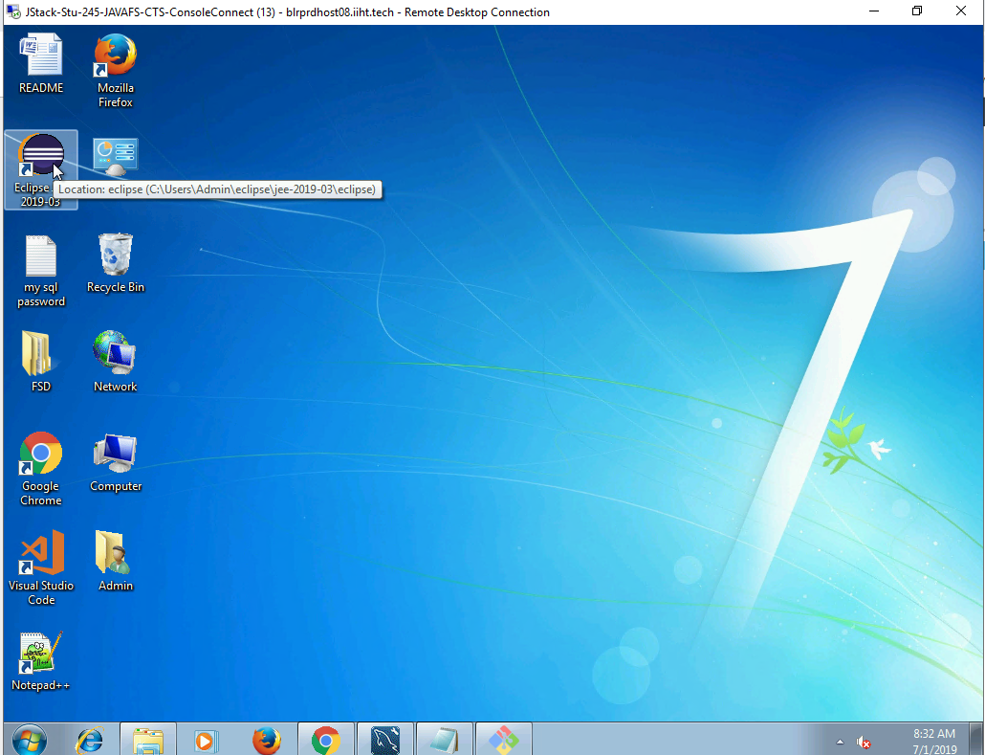

Click launch

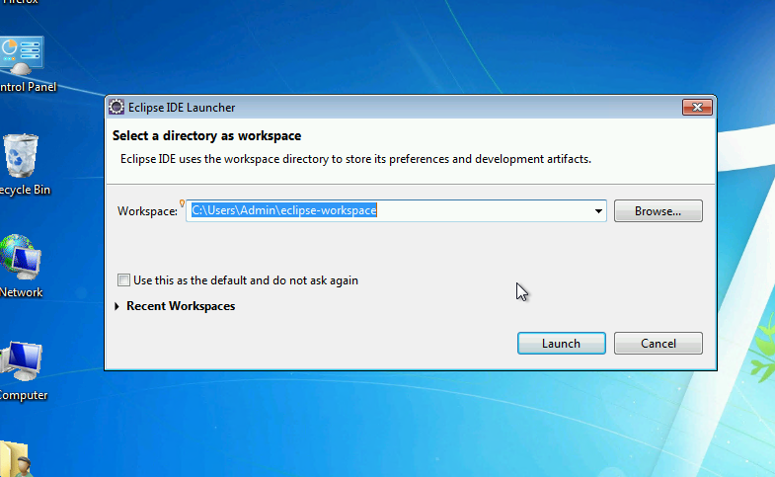

Click on Run-> Tomcatv7.0 Server At Localhost

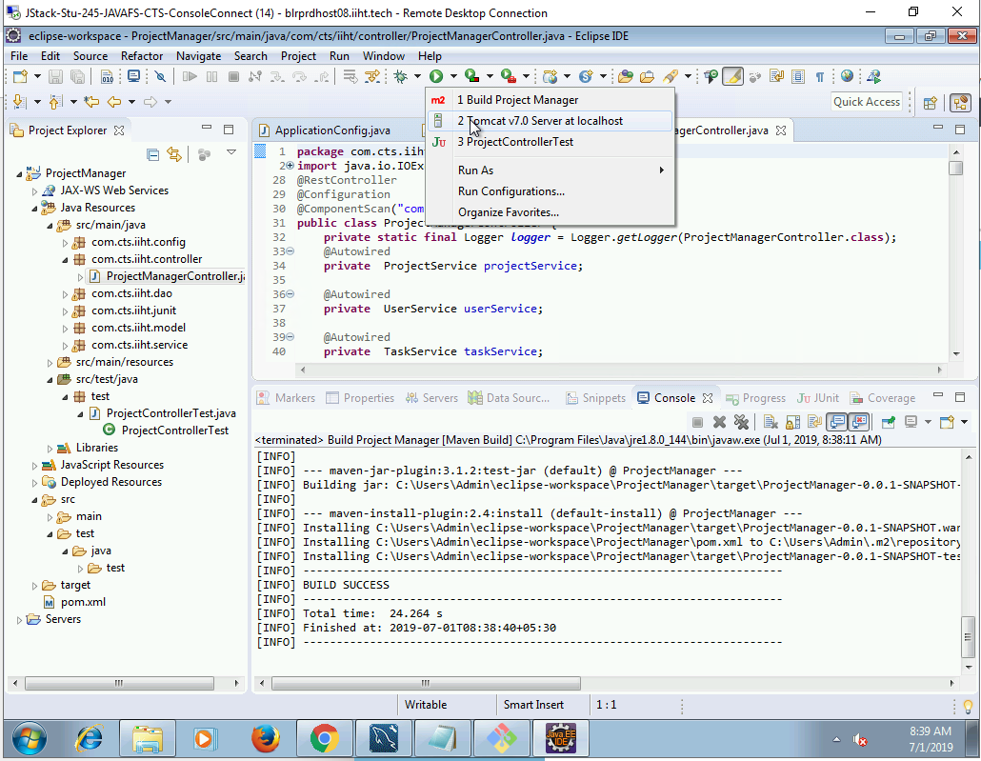

At successful start up of tomcat

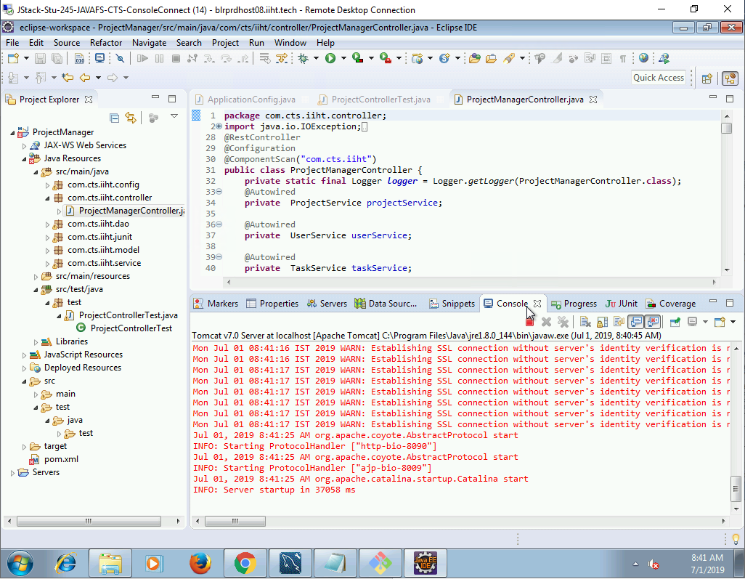

Kindly launch the below url:

Localhost:8090/ProjectManager/index.html

